Bare Root Trees
2018

FRUIT TREES

Almonds
All In One

Apples
Fuji
Gala
Golden Delicious
Granny Smith
Johnathan
Pink Lady
Red Delicious
Pixie Crunch
Crimson Crisp
Cox Orange Pippin
Pomme De Neige
Trixzie Miniature Gala
Trixzie Miniature Pink Lady
Ballerina Bolero
Ballerina Charlotte
Ballerina Maypole
Ballerina Waltz

Apricots
Moorpark
Tilton
Trevatt

Cherries
Stella / Sunburst
Lapins / Sir Don
Morello / Napoleon
Royal Rainer
Starkrimson
Trixzie Black Cherree
Trixzie White Cherree

Chestnuts
Seedling
April Gold SOLD OUT
Flemings Prolific
Flemings Special
Marone SOLD OUT
Emerald Gem SOLD OUT

Figs
Brown Turkey
Black Genoa
Preston Prolific
White Adriatic

Hazelnuts
Cosford
Red Aveline
American White
Barcelona
Halls Giant
Wanliss
Seedling

Mulberry
Black English
Hicks Fancy

Nectarines
Fantasia
Flavourtop SOLD OUT
Goldmine
New Boy
Arctic Rose
Peacharine
Trixzie Nectazee

Peaches
Anzac
Black Boy
Red Noonan
Okee Dokee SOLD OUT
Crimson Rocket SOLD OUT
Golden Queen
Red Haven
Tasty Zee
Daisy

Pears
Beaure Bosc
Josaphine
Packham’s Triumph
Williams
Chojuro
Nijisseiki
Corelloa
Red D’anjou
Yali
Sensation
Baby Face
Trixzie Pyvert Pear

Plums
Damson
Green Gage
Mariposa
Santa Rosa
Satsuma
Angelina
Sugar Plum
Louisa
President

Persimmon
Fuyu SOLD OUT
Dai Dai SOLD OUT

Quince
Champion
Smyrna

Walnuts
Chandler SOLD OUT
Franquette SOLD OUT
Seedling

FLOWERING ORNAMENTALS

Prunus Cherry
Kanzan
Mt Fuji
J.H Veitch-Fugenzo

Prunus Plums
Elvins
Blireana

Prunus Peach
Magnifica
Versicolour

Malus
Julia’s Blush SOLD OUT
Floribunda
Ioensis Plena
Royal Raindrops
Sugar Tyme
Wychwood Ruby
Gorgeous
Tom Matthews
Crimson Knight
Showtime
Golden Raindrops

Cornus
Red Beauty

Cercis
Forest Pansy
Chain Of Hearts
Oklahoma

Multi Graft Trees
2 Way Apple
Crimson Crisp/ Pixie Crunch
2 Way Cherry
Royal Rainer/Stella
2 Way Nectarine
Goldmine/May Grand
2 Way Okee Dokee
Nectarine/ Peach
2 Way Pear
Packhams Triumph/ Williams
2 Way Plum
Flavour Supreme/Mariposa

Pyrus Pear
Chanticleer
Bradford
Manchurian
Aristocrat

Lilacs
Alice Eastwood
Charles Joly
Belle De NancySOLD OUT
Congo
Cora Brandt
Clark’s Giant SOLD OUT
Katherine Havemeyer
SOLD OUT
Mrs Edward Harding
SOLD OUT
Persica SOLD OUT

Crepe Myrtle
Acoma
Comanche
Zuni
Tuscarora
Natchez

Magnolia
Black Tulip SOLD OUT
Cleopatra SOLD OUT
Burgundy Star SOLD OUT
Soulangeana
Stellata SOLD OUT
Vulcan SOLD OUT

3 Way Apple
*Crimson Crisp/Pixie Crunch/ Williams Pride
*Gala/ Pink Lady/ Red Fuji
3 Way Nectarine
*Fantasia/ Goldmine/ Maygrand
3 Way Peach
*Double Jewel/Redhaven/Tasty Zee
3 Way Pear
Beurre Bosc/Packham/Williams
3 Way Plum
Flavour Supreme/Mariposa/Santa Rosa
3 Way Peach
Double Jewel/Queen Giant/Tasty Zee

SHADE TREES

Aesculus
Indian Horse Chestnut

Acer
Autumn Blaze
October Glory
Sensation
Sango Kaku
Pacific Sunset
Scarlet Sentinel

Betula
Silver Birch
Moss White SOLD OUT
White Spire
Dalecarlica

Catalpa
Indian Bean Tree SOLD OUT
Purple Bean Tree SOLD OUT

Corylius
Contorted Purple Leaf SOLD OUT

Fraxinus
Claret Ash
Golden Ash

Liriodendron
Tulip Tree SOLD OUT

Platanus
London Plane

Quercus
English Oak
Scarlet Oak
Pin Oak

Salix
Weeping Willow

Sophora
S. Princeton Upright

Tilia
Cordata

Ulmus
Golden Elm
Emperor Todd

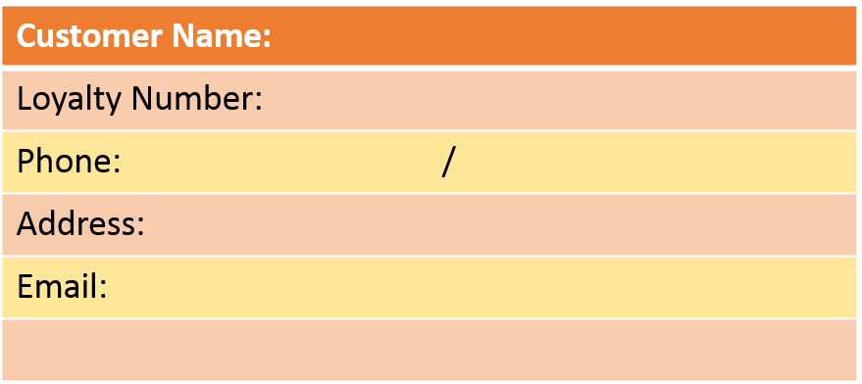

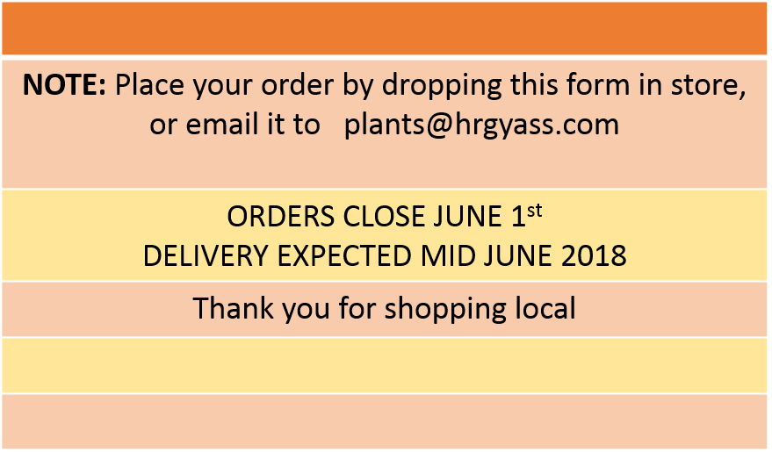

Weeping/Standard Trees
A.Palmatum Dissectum Atropurpureum
A.Palmatum Dissectum Inaba Shidare

A.Palmatum Dissectum Shojo Shidare

Prunus Snow Fountains
Prunus Cheal’s Weeping
Prunus Mume Apricot

Pyrus Salicifolia Weeping Pear

Weeping Mulberry

Catalpa Indian Bean Tree
SOLD OUT

Betula Youngii
Betula Summer Cascade
Betula Lollipop

Robinia Mop Top

